Inherited mother's land, converted it into business stock, and invested over Rs 5 crore in a new home; ITAT Surat grants Section 54F tax exemption relying on a 1983 CBDT circular; Know why
https://economictimes.indiatimes.com/wealth/tax/inherited-mothers-land-converted-it-into-business-stock-and-invested-over-rs-5-crore-in-a-new-home-itat-surat-grants-section-54f-tax-exemption-relying-on-a-1983-cbdt-circular-know-why/articleshow/133286668.cms?utm_source=contentofinterest&utm_medium=text&utm_campaign=cppst
Mr Patel, who hails from Khatodara in Surat, Gujarat, is a co-owner of his late mother’s land in Althan. This plot, spanning 9,510 sq. meter was originally bought for Rs 21.17 lakh by his mother on March 31, 2008. After her death, he inherited 50% of this land and decided to use it as stock for his real estate business. On April 1, 2017, he legally converted this land into stock-in-trade and included it in his real estate business.
For those who might not know, if you want to convert any inherited land held as a capital asset to stock-in-trade for business use, you need to first convert the capital asset into a business asset. This means you need to follow the fair market value and other tax laws. Mr Patel followed the legal requirements and reported a long term capital gain (LTCG) of Rs 5.06 crore under Section 45(2). However, he did not pay any tax on this LTCG.
The reason he avoided paying any tax on this Rs 5.06 crore LTCG is because Patel filed his income tax return (ITR) claiming that he had purchased another land for Rs 2.13 crore and constructed a house on that land which pushed his total construction cost to Rs 5.06 crore, making him eligible for a full tax exemption under Section 54F.
The following are the reasoning and calculations given by Patel to the tax department:
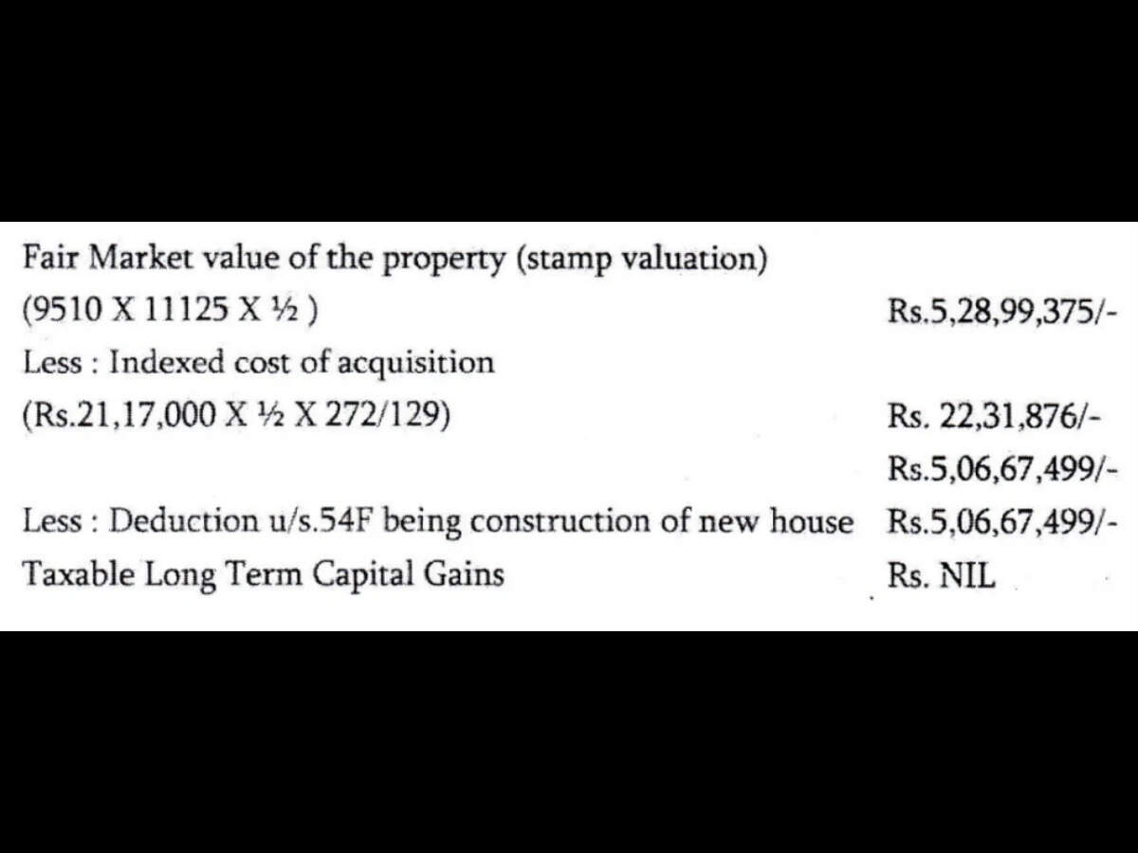
The Income Tax Assessing Officer rejected both Patel’s reasoning and the Section 54F tax exemption claim. First, the AO selected his ITR for limited scrutiny assessment, and then made an assessment order where Patel’s total income was assessed at Rs 2.91 crore (after current year business loss set off of Rs 1.59 crore). The AO also made a single addition of Rs 4.51 crore on account of Long Term Capital Gain and rejected the claim of deduction under Section 54F.
When the case reached the Income Tax Appellate Tribunal (ITAT) Surat, the income tax department said that Patel had bought this Rs 2-crore land even before using his mother’s land as business stock and also did not use the LTCG to construct the new house before the ITR filing due date.
T.R. Senthil Kumar, Judicial Member and Shri. Ratnesh Nandan Sahay, Accountant Member of ITAT Surat heard his case on April 30, 2026, and passed its judgement on July 10, 2026. The tribunal ruled that Patel can claim Section 54F tax exemption even in the circumstances described above, meaning that Patel does not need to pay any tax. Chartered Accountant Dhruvang Diwan represented Patel in ITAT Surat.
While deciding this case, ITAT Surat referred to a Central Board of Direct Taxes circular (No. 359 dated May 10, 1983) which dealt with Section 54E. ITAT Surat observed that this circular supported the broader principle that a capital-gains exemption should not be denied merely because an eligible investment was made before the formal transfer where the substantive objective of the provision had been fulfilled. (incometaxindia.gov.in/w/359-circular-no.-359-dated-10-05-1983).

Summary of the judgement
Chartered Accountant Suresh Surana said ET Wealth Online that this case, ITAT Surat decided on the issue whether Section 54F tax exemption could be claimed by an individual if the unutilised amount was not deposited in the Capital Gains Account Scheme before the ITR filing due date as per Section 139 (1), even though the unutilised amount ultimately was used to invest for building a residential house within three prescribed three year time period.
According to Surana, on the first issue, the ITAT Surat held that Section 54F requires a taxpayer to construct a residential house within three years from the date of transfer. ITAT Surat observed that the law does not stipulate that the land on which the house is constructed must also be purchased after the transfer.
Thus ITAT Surat said that they could not introduce an additional condition that the Legislature had not expressly included in the Section 54F law. What was material was that the residential house was completed within the prescribed period and that the consideration was invested towards its construction.
The tax tribunal further observed that land is an inseparable and integral part of a residential house. Excluding the land cost while allowing the cost of the superstructure would artificially divide the residential property and defeat the objective of Section 54F.
Surana says that in arriving at this conclusion, the tax tribunal relied upon the Karnataka High Court’s ruling in the CIT v. J.R. Subramanya Bhat and the Madras High Court’s decision in the C. Aryama Sundaram v. CIT cases.
Regarding to CGAS issue, the ITAT Surat observed that Section 54F says that CGAS is used to preseve the tax benefit on the unutilised funds until the funds can be invested in a new residential house as per the prescribed conditions of Section 54F.
So Patel did invest the unutilised funds in a new residential house within the statutory three years and this fact was not disputed by the Income Tax Department. However, Patel did not deposit the unutilised money in CGAS account.
Thus ITAT referred to a related case of CIT v. K. Ramachandra Rao and held that Patel's Section 54F tax exemption could not be denied solely because the amount had not first been deposited in a CGAS prescribed account.
The tax tribunal also referred to CBDT Circular No. 359 dated May 10, 1983.
Surana says that although that circular concerned Section 54E, it supported the broader principle that a capital-gains exemption should not be denied merely because an eligible investment was made before the formal transfer where the substantive objective of the provision had been fulfilled.
Surana says: “Since Section 54F is a beneficial provision intended to encourage investment in residential housing, the tax tribunal adopted a purposive interpretation.”

Why did Mr Patel win the case?
Surana says that Mr Patel succeeded because he had fulfilled the substantive conditions of Section 54F: the expenditure related to the same residential house. The house was constructed within the prescribed three-year period, and the investment was genuine and undisputed.
The Income Tax department’s objections were based primarily on the timing of the plot purchase and non-deposit in the Capital Gains Account Scheme.
The tax tribunal held that these factors could not override the actual completion of the qualifying investment within the statutory period.
Accordingly, ITAT Surat upheld the CIT(A)’s order and dismissed the tax department’s appeal.
Surana says: “This ruling as discussed in this article should, however, be understood in its factual context. It does not dispense with the Capital Gains Account Scheme requirement in every case.”
Mihir Tanna, associate director, S.K Patodia LLP says: It would be very helpful for genuine home buyers if income tax issue some clarification on such issues. We have observed litigation in certain cases wherein question before court was whether taxpayer is eligible to claim tax exemption on on prescribed long term capital gain.
Tanna says that broadly litigation arises in following scenarios wherein the required amount is invested in new property after date of transfer of asset on which tax exemption claimed within prescribed time limit and main intention of legislature is achieved :
- Land is acquired for construction before date of transfer of asset on which exemption claimed but required amount is spent in construction cost.
- Flat is booked with builder before date of transfer of asset but required amount is paid to builder after date of sale
- Construction started before date of transfer of asset but required amount is paid to builder after date of sale
- Amount is paid for acquisition through home loan and amount repaid after date of transfer of asset.
- Required amount is paid to builder for new home after date of sale but builder could not complete construction within 3 years
---------------------

